**Advanced Construction Techniques in Git: Stashing, Reviving, Merging, and Rebasing**

Now that your castle's foundation is laid and you've mastered basic housekeeping, let's explore some advanced techniques for managing your project's history:

**Understanding the Stash ("git stash")**

Imagine you're in the middle of building a magnificent tower (feature) but need to switch tasks urgently. You don't want to lose your progress (unstaged changes), but you also don't want to clutter your current work with them. The git stash command acts like a temporary storage chest for your unfinished work. You can stash your unstaged changes, switch tasks, and then retrieve your stashed work later when you're ready to resume building the tower.

**Algorithm for Using Git Stash:**

1. Run git stash to save your unstaged changes.
2. (Optional) Add a descriptive message with git stash save "<message>".
3. Switch tasks or branches as needed.
4. When you're ready to resume, run git stash pop to retrieve your latest stashed changes.

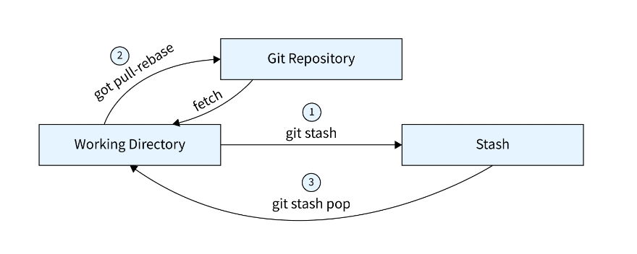

**Bringing Lost Data Back with "git reflog"**

Sometimes, even the most organized architect misplaces something. The git reflog command acts like a detailed logbook of all your Git operations (commits, stashes, branch changes). If you accidentally discard changes or lose track of a specific commit, git reflog can help you find it and potentially recover it.

**Algorithm for Using Git Reflog:**

1. Run git reflog to see a list of recent Git operations.
2. Identify the commit you're looking for by its hash (a unique identifier).
3. Use specific commands like git checkout <commit_hash> or git reset --hard <commit_hash> to recover the commit (use these commands with caution!).

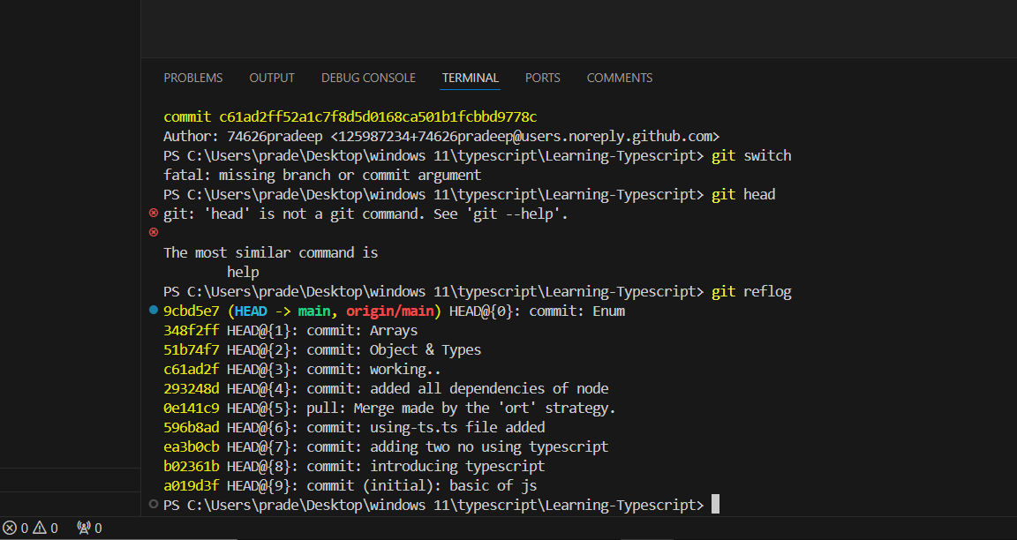

**Combining Branches - What & Why?**

As your castle grows, you might have multiple branches (designs) under construction. At some point, you'll need to integrate the best parts of each branch into your main castle (master branch). This is where merging comes in. Merging is like combining different blueprints (branches) into a single, unified design.

**Understanding Merge Types**

There are two main types of merges:

* **Fast-Forward Merge:** This is the simplest type, where the history of the branch being merged is linear (no branching off). It's like seamlessly integrating a new section of your castle blueprint (branch) into the main blueprint (master branch).
* **Recursive Merge (Non-Fast-Forward):** This occurs when the branch being merged has diverged from the main branch (created branches of its own). It's like merging two separate blueprints (branches) that have been modified independently. In this case, Git might create a "merge commit" to record the merging process.

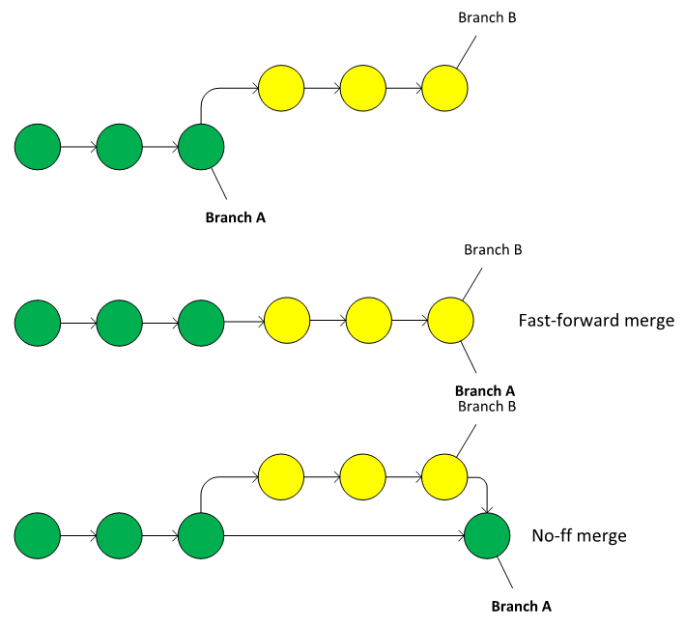

**Applying the Fast-Forward Merge**

When you use git merge <branch_name> on a branch with a linear history, Git performs a fast-forward merge. It's like seamlessly extending your main blueprint (master branch) to include the changes from the other branch.

**The Recursive Merge (Non-Fast-Forward)**

If the branch you're merging has a more complex history, Git will perform a recursive merge. It might create a new "merge commit" to record the merging process and resolve any conflicts between the branches.

**Rebasing - Theory**

Rebasing is a more advanced technique for integrating changes from one branch (usually a feature branch) onto another branch (usually the master branch). It's like rewriting history (carefully!) by taking the commits from your feature branch and applying them on top of the latest state of the master branch. This can result in a cleaner, linear history, but it can also be confusing for collaborators if not used judiciously.

**Applying "git rebase"**

To rebase a branch, you use the git rebase <branch_name> command. Git will replay the commits from your feature branch onto the current state of the master branch, potentially creating new commits in the process.

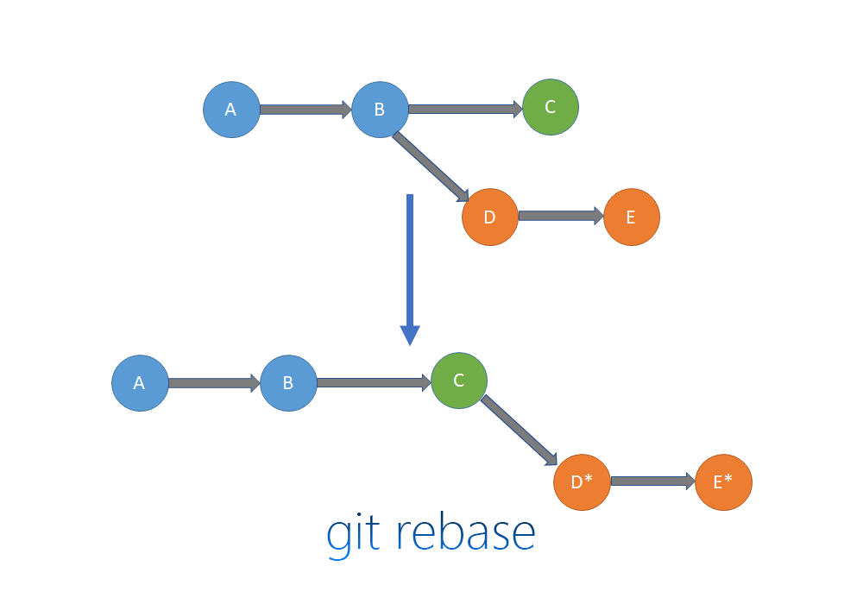

**Handling Merge Conflicts**

Sometimes, when merging or rebasing branches, Git might encounter conflicts. These occur when the same lines of code have been modified differently in both branches. Git will halt the process and present you with the conflicting sections, requiring you to manually resolve them by editing the code.

**Merge vs Rebase vs Cherry Pick**

* **Merge:** This is a more straightforward approach for integrating changes, suitable for simple projects or when collaboration is important. It preserves the history of all branches involved.
* **Rebase:** This can create a cleaner history but can be confusing for collaborators
* Imagine cherry-picking as a treasure hunt for brilliant ideas. You meticulously search through another architect's design (branch) and handpick specific, valuable ideas (commits) to incorporate into your own castle (master branch). This allows you to selectively integrate specific solutions without needing the entire blueprint (branch history).

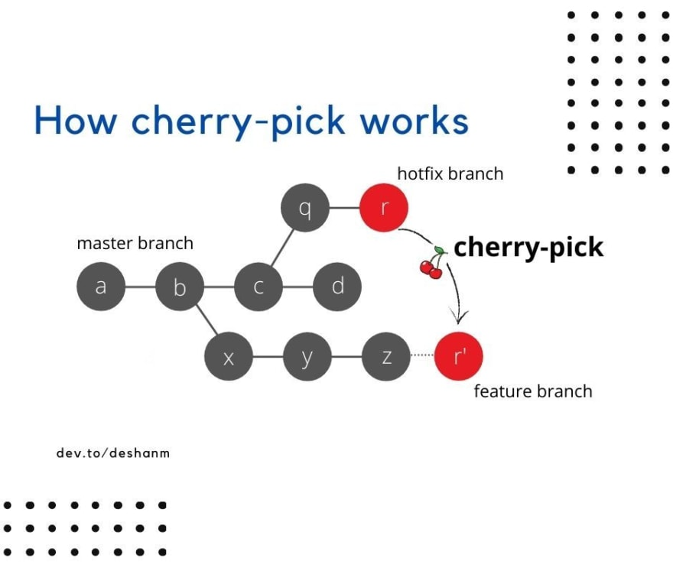

**Cherry-Pick: Selecting the Best Parts**

Imagine cherry-picking as a treasure hunt for brilliant ideas. You meticulously search through another architect's design (branch) and handpick specific, valuable ideas (commits) to incorporate into your own castle (master branch). This allows you to selectively integrate specific solutions without needing the entire blueprint (branch history).

**Algorithm for Cherry-Picking a Commit:**

1. Identify the commit hash (unique identifier) of the commit you want to cherry-pick. Use git log to find it.
2. Run the command git cherry-pick <commit_hash>.
3. Git will attempt to apply the selected commit to your current branch.
4. If there are conflicts (changes to the same lines of code), Git will halt the process and require you to resolve them manually.

**Use Cherry-Pick When:**

* You need to integrate a specific, well-defined change (like a bug fix) from another branch.
* You want to avoid cluttering your main branch history with unnecessary commits.
* You understand the potential complexity of a non-linear history.

**Understanding "git tag"**

**The git tag command allows you to create lightweight pointers that reference specific commits in your Git repository. Think of them as engraved plaques placed at key points in your castle's construction. These tags make it easy to navigate back to those specific versions of your project later.**

**Algorithm for Creating a Tag:**

1. **Use git log to identify the commit hash (unique identifier) of the commit you want to tag.**
2. **Run the command git tag <tag_name> <commit_hash>. Replace <tag_name> with a descriptive name for your milestone and <commit_hash> with the actual hash.**
3. **(Optional) Add an annotation message with git tag -a <tag_name> -m "<message>" to provide more context about the tag.**

**Benefits of Using Tags:**

* **Version Control: Tags act as signposts, allowing you to easily jump back to specific versions of your project for testing, debugging, or reference.**
* **Collaboration: Tags can be helpful for collaborators working on different parts of the project. They can quickly access specific versions based on tag names.**
* **Release Management: Tags can be used to mark releases of your project (like v1.0, v2.1).**

**Remember: Tags are lightweight and don't create new commits themselves. They simply reference existing commits in your history.**